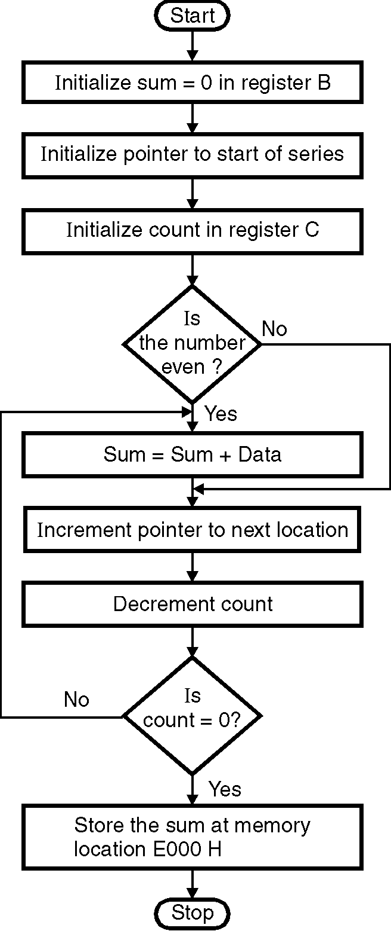
ØØ Explanation :
- Initialize the sum to zero. Load the count of numbers in register C. Initialize pointer to start of series.
- To check whether the number is even we will AND the number with 01 H. If the result of ANDing is zero it indicates that the number is even. We will add this even number to the initialised sum.
- Decrement count. Increment source pointer to next location. Continue the process till sum of all even numbers is found. Store the sum at memory location E000 H.
ØØ Algorithm :
Step I : Initialize sum in B = 00.
Step II : Initialize pointer to start of series i.e.
D001 H. Initialize counter 1 = 10.
Step III : Check if number is even.
If not goto step V.
Step IV : Sum = Sum + Data.
Step V : Increment pointer.
Step VI : Decrement counter.
Step VII : Check if count = 0. If not go to step IV.
Step VIII : Store result in memory location E000 H.
Step IX : Stop.
ØØ Flowchart : Refer flowchart 30.
ØØ Program :
Instruction Comment
LDA D000H
MOV C, A ; Initialize counter
MVI B, 00H ; sum = 0 Flowchart 30
LXI H, D001H ; Initialize pointer
BACK: MOV A, M ; Get the number
ANI, 01H ; Mask Bit1 to Bit7
JNZ SKIP ; Don’t add if number is ODD
MOV A, B ; Get the sum
ADD M ; SUM = SUM + data
MOV B, A ; Store result in B register
SKIP: INX H ; increment pointer
DCR C ; Decrement counter
JNZ BACK ; if counter 0 repeat
STA E000H ; store sum
HLT ; Terminate program execution

